**MET’S INSTITUTE OF INFORMATION TECHNOLOGY**

**(CDAC-ACTS)**

**BHUJBAL KNOWLEDGE CITY, NASHIK**

Documentation On

“Sky-High Adventures: The Ultimate Adventure Park Solutions’’

PG-DAC August 2024

*Submitted By:*

**Group No: 3**

**Names: Ashutosh Shinde (240847320009)**

**Tanmay Tarwade (240847320065)**

**Priyanka Jadhav (240847320045)**

**Gayatri Kedar (240847320016)**

**Mr. Nandkishor P. Sonawane Mr.Rushikesh Majale**

**Centre Coordinator Project Guide**

# Table of Contents

1. [**Introduction**](https://docs.google.com/document/d/1gmYFXztGC68-7Tot-psYQgrJNfWd4TRCWartI0UCQfM/edit#heading%3Dh.gjdgxs)
   1. [Problem Statement](https://docs.google.com/document/d/1gmYFXztGC68-7Tot-psYQgrJNfWd4TRCWartI0UCQfM/edit#heading%3Dh.30j0zll)
   2. Aim & Objectives
2. [**Overall Description**](https://docs.google.com/document/d/1gmYFXztGC68-7Tot-psYQgrJNfWd4TRCWartI0UCQfM/edit#heading%3Dh.1fob9te)
   1. [Proposed Methodology](https://docs.google.com/document/d/1gmYFXztGC68-7Tot-psYQgrJNfWd4TRCWartI0UCQfM/edit#heading%3Dh.3znysh7)
   2. [Design and Implementation Constraints](https://docs.google.com/document/d/1gmYFXztGC68-7Tot-psYQgrJNfWd4TRCWartI0UCQfM/edit#heading%3Dh.tyjcwt)
3. [**Requirements Specification**](https://docs.google.com/document/d/1gmYFXztGC68-7Tot-psYQgrJNfWd4TRCWartI0UCQfM/edit#heading%3Dh.3dy6vkm)
   1. [External Interface Requirements](https://docs.google.com/document/d/1gmYFXztGC68-7Tot-psYQgrJNfWd4TRCWartI0UCQfM/edit#heading%3Dh.1t3h5sf)
4. **System Diagram** 
   1. [Data Flow Diagram](https://docs.google.com/document/d/1gmYFXztGC68-7Tot-psYQgrJNfWd4TRCWartI0UCQfM/edit#heading%3Dh.4d34og8)
   2. Project Architecture Diagram
   3. [ER Diagram](https://docs.google.com/document/d/1gmYFXztGC68-7Tot-psYQgrJNfWd4TRCWartI0UCQfM/edit#heading%3Dh.2s8eyo1)
5. [**Table Structure**](https://docs.google.com/document/d/1gmYFXztGC68-7Tot-psYQgrJNfWd4TRCWartI0UCQfM/edit#heading%3Dh.17dp8vu)
   1. Users
   2. Admin
   3. Booking
   4. Activity Booking
   5. Offer/Event
   6. Payment
   7. Review
6. **Screenshots**
7. **Conclusion** 
   1. [Future Scope](https://docs.google.com/document/d/1gmYFXztGC68-7Tot-psYQgrJNfWd4TRCWartI0UCQfM/edit#heading%3Dh.3rdcrjn)
8. **References**
9. **INTRODUCTION**

## Introduction:

The Sky-High Adventure: The ultimate adventure park Web Application is an innovative platform designed to transform the visitor experience at adventure parks through advanced technology and real-time data integration. This application provides users with a comprehensive suite of features, including an interactive map of park attractions, live updates on wait times, and personalized itineraries based on user preferences and interests. The Sky-High Adventure: The ultimate adventure park enhances every aspect of a visitor's journey, from automated booking and personalized adventure recommendations to live tracking of park activities and real-time safety measures. With features such as interactive maps, smart equipment, and dynamic scheduling, visitors can enjoy a highly immersive and efficient experience, while operators can optimize resources and improve guest satisfaction.

## Problem Statement:

## Traditional adventure parks often face several challenges that can impact the overall visitor experience, operational efficiency, and safety. These challenges include long waiting times, inefficient resource management, limited personalization of activities, and the need for improved safety monitoring. Visitors frequently struggle with navigating large, complex parks, leading to confusion and wasted time. Furthermore, managing crowd flow, ensuring safety standards, and providing personalized recommendations based on visitor preferences remain difficult tasks for park operators. The lack of real-time data and communication between various park systems can also result in delayed responses to emergencies or unoptimized scheduling of park attractions. Moreover, the inability to track visitors' activity, preferences, and safety status limits the park’s capacity to enhance the overall guest experience and improve operational efficiency.

## Aims and Objective:

The aim of this project is to develop an Activity and Booking Management System for a Sky-High Adventure that enhances the user experience by providing efficient booking, dynamic activity suggestions, seamless payment integration, and personalized itineraries. The system will leverage technologies such as payment gateways, weather-based activity recommendations, and smart queue management to optimize park operations, reduce wait times, and ensure a more enjoyable and streamlined experience for visitors. Additionally, the platform will offer secure user authentication, review and feedback functionalities, and allow for real-time updates to ensure the smooth functioning of the park.

**Sky-High Adventure: The ultimate adventure park** **portal has, following objectives:**

• **Activity Booking System:** To develop an efficient system where users can easily select and book activities, choose available time slots, make secure payments, and receive booking confirmations via email.

• **User Authentication:** To implement a secure registration and login system, utilizing JWT (JSON Web Tokens) or session management, to protect user accounts and personal information.

• **Payment Integration:** To integrate reliable and secure payment gateways such as PayPal, Razor pay, and Stripe, ensuring smooth transactions for users. The system should handle payment statuses, refunds, and invoicing efficiently.

• **Reviews & Feedback:** To allow users to leave reviews, provide star ratings, and submit feedback for activities, fostering community engagement. Implement an admin panel where reviews can be moderated to ensure quality control.

• **Dynamic Weather-Based Activity Suggestions:** To incorporate a weather API that adjusts activity suggestions in real-time based on weather conditions (e.g., recommending water activities on sunny days and indoor activities on rainy days).

• **Smart Queue Management & Virtual Waitlists:** To implement a virtual queue system where visitors can join waitlists for popular activities and receive notifications when it’s their turn, reducing physical wait times and enhancing the overall visitor experience.

• **Personalized Adventure Itineraries:** To enable users to create personalized itineraries based on their preferences, interests, and age. The system should suggest activities, breaks, and meal times, ensuring a well-balanced and optimized adventure schedule.

# OVERALL DESCRIPTION

## Proposed Methodology:

The purpose of this project is to design and develop a **Sky-High Adventure System** that integrates advanced technologies to enhance both the visitor experience and park operations. By incorporating features like seamless activity booking, dynamic weather-based activity suggestions, secure payment processing, smart queue management, and personalized itineraries, the system aims to optimize park workflows, reduce visitor wait times, and offer a highly personalized adventure experience. The project will also ensure safety, improve resource management, and provide a more engaging and enjoyable environment for park visitors, all while improving operational efficiency for the park management.

The methodology for this project follows a structured approach to ensure a seamless development process. It begins with requirement gathering, where the needs and expectations of park operators and visitors are carefully analyzed. This step includes identifying challenges in current park systems, such as inefficient booking and long wait times. Next, the system design phase focuses on creating an architecture that includes both frontend and backend components, ensuring the user interface is intuitive while the backend can handle complex functions like activity scheduling, payment integration, and real-time data processing. During development, both frontend (using web technologies like HTML, CSS, and React JavaScript) and backend (using frameworks such as Spring boot Java) are implemented, with careful integration of key services like payment gateways (Razor pay) and weather APIs for dynamic activity recommendations.

An adventure park typically features challenging obstacle courses, zip lines, rock climbing, high ropes courses, and other physical adventures that encourage visitors to push their limits, build confidence, and enjoy nature. These parks may also include activities like canoeing, mountain biking, or safari-style adventures that provide guests with an opportunity to explore various terrains, all while being surrounded by scenic landscapes.

## Design and Implementation Constraints:

**1. System Type**

* The system is a **fully web-based application**, accessible through a modern web browser.
* **Frontend:** React.js with Redux for state management.
* **Backend:** Spring Boot (J2EE) with RESTful APIs.
* **Database:** MySQL (relational database for handling all park-related data).
* **Security:** JWT-based authentication, OAuth2 for third-party authentication (Google).

**2. Scalability**

* The system should support **at least 500 concurrent users** efficiently.
* Optimized database indexing for faster queries.
* **Load balancing** to distribute requests across multiple servers

**3. Security Considerations**

* **Role-Based Access Control (RBAC):** Admin, User, and Visitors will have different permissions.
* **Data Encryption:** All sensitive user data (passwords, payment details) will be encrypted using **BCrypt**.
* **Secure API Calls:** All API endpoints must be secured using HTTPS and CORS policies.

**User Experience**

* The UI must be **responsive** and **mobile-friendly** for smooth operation on desktops, tablets, and mobile devices.
* **Intuitive Dashboard:** Admins should have access to real-time reports and analytics.

**4. Third-Party Integrations**

* **Payment Gateways:** Stripe, Razor pay, or PayPal for secure online payments.
* **Google Maps API:** For park location, navigation, and mapping rides.
* **Email Notifications:** Automated ticket confirmations and updates.

# REQUIREMENTS SPECIFICATION.

## External Interface Requirements:

User Interface (UI)**:**

* **Technology:** React.js
* **Communication Mode:** HTTPS Requests (REST API)
* **Interfaces:**
  + User Authentication (Login/Registration)
  + Ticket Booking & Payments
  + Ride Booking available time slots
  + Notifications (Email)

Hardware Interfaces:

* **Database Server** – Hosts relational databases like MySQL to store user data, booking details, and payment records.
* **Application Server** – Runs the backend services (J2EE Spring Boot) to handle business logic and API requests.
* **Web Server** – Hosts the React frontend and serves web-based user interfaces for customers and administrators.
* **Payment Gateways** – Supports online and offline payment processing through cards, mobile wallets, or Razor-pay.

Application Interfaces:

1. **Web Browser Interface:**

The system is a **web-based application**, requiring users to access it through a modern web browser such as:

* **Google Chrome**
* **Mozilla Firefox**

Users must have an **active internet connection** to interact with the system.

**2. User Interfaces:**

* **User Portal:** Accessible via web browsers for online ticket booking, ride information, and payments.
* **Admin Dashboard:** Provides system administrators with tools for managing bookings, users, and park operations.

**3. API Interfaces:**

* **RESTful APIs** – The system exposes APIs for communication between the **React frontend** and **Spring Boot backend**.
* **Third-Party Payment Gateway APIs** – Secure integration with online payment providers for transactions.

Communications Interfaces:

**1. User Interface (UI) - Frontend & Client-side Communication**

* **Technology:** React.js
* **Communication Mode:** HTTPS Requests (REST API)
* **Interfaces:**
  + User Authentication (Login/Registration)
  + Ticket Booking & Payments
  + Ride Booking available time slots
  + Notifications (Email)

**2. Backend Communication - API Layer**

* **Technology:** J2EE Spring Boot
* **Communication Mode:** RESTful APIs / WebSocket
* **Interfaces:**
  + REST APIs for CRUD operations on users, rides, tickets, and payments
  + WebSocket for real-time updates (ride availability, wait times, safety alerts)
  + Authentication & Authorization (JWT, OAuth)

**3. Database Communication**

* **Technology:** MySQL
* **Communication Mode:** JDBC (Java Database Connectivity)
* **Interfaces:**
  + User & Admin Data Storage
  + Ride & Attraction Information
  + Ticket & Payment Records

**5. Payment Gateway Communication**

* **Technology:** Stripe / Razor pay / PayPal API
* **Communication Mode:** HTTPS API Calls
* **Interfaces:**
  + Secure Payment Processing

# SYSTEM DIAGRAMS

**Flow Chart**

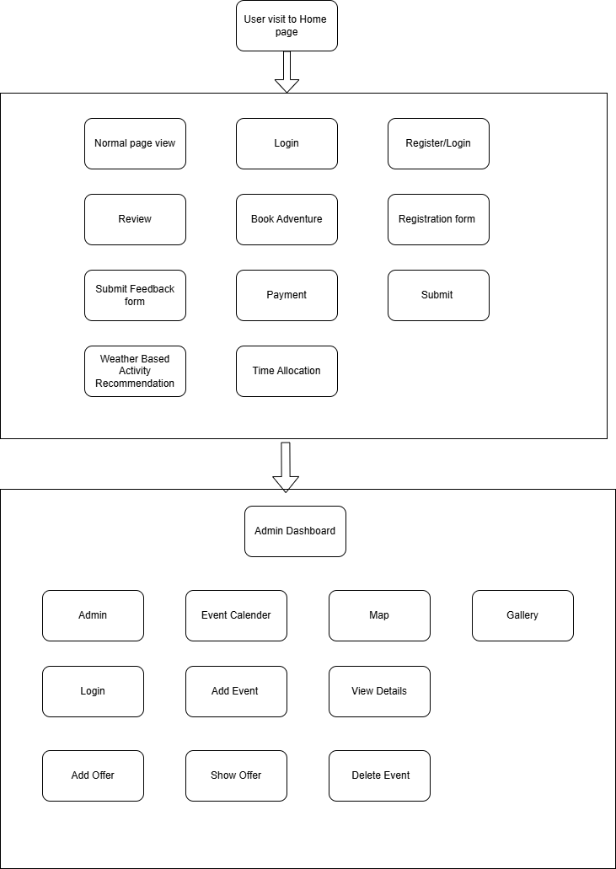

# 

# Project Architecture Diagram:

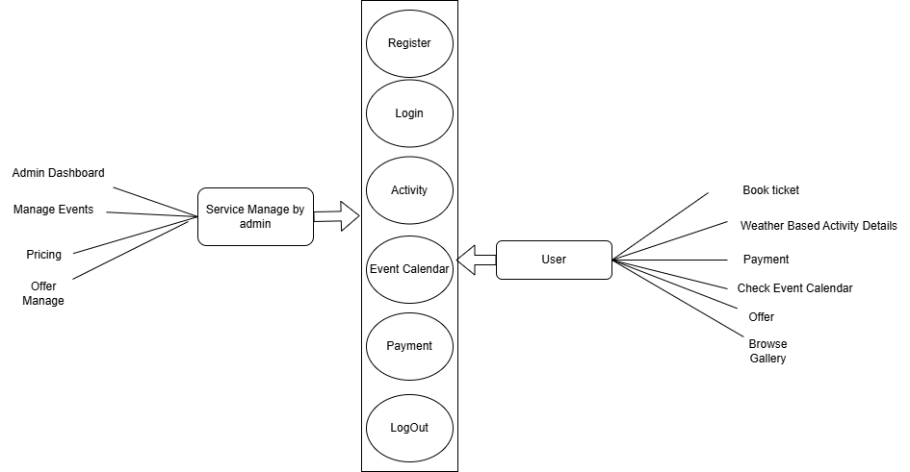

**ER Diagram**

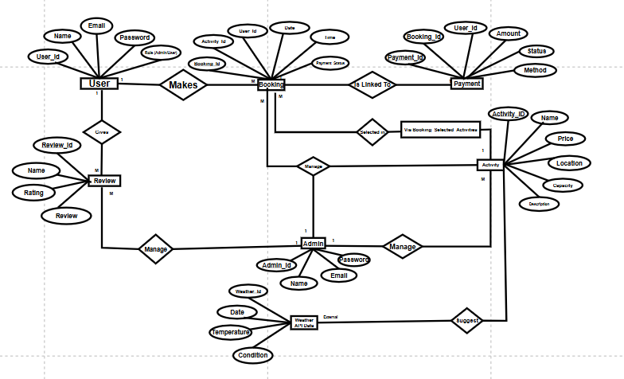

1. **TABLE STRUCTURE**

User Table:

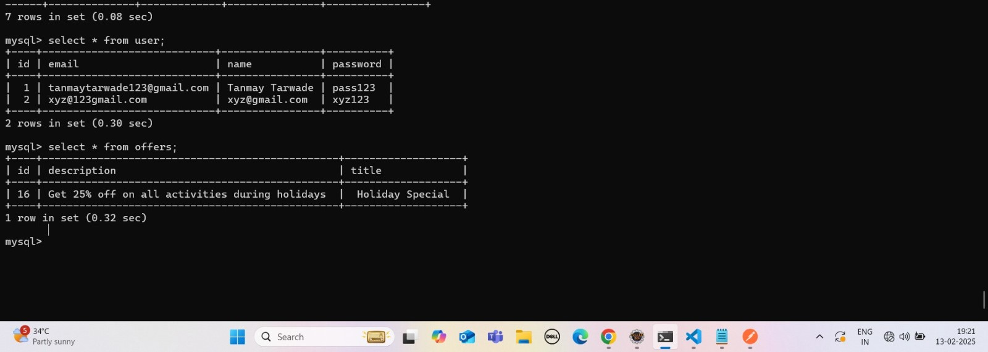

Booking Table:

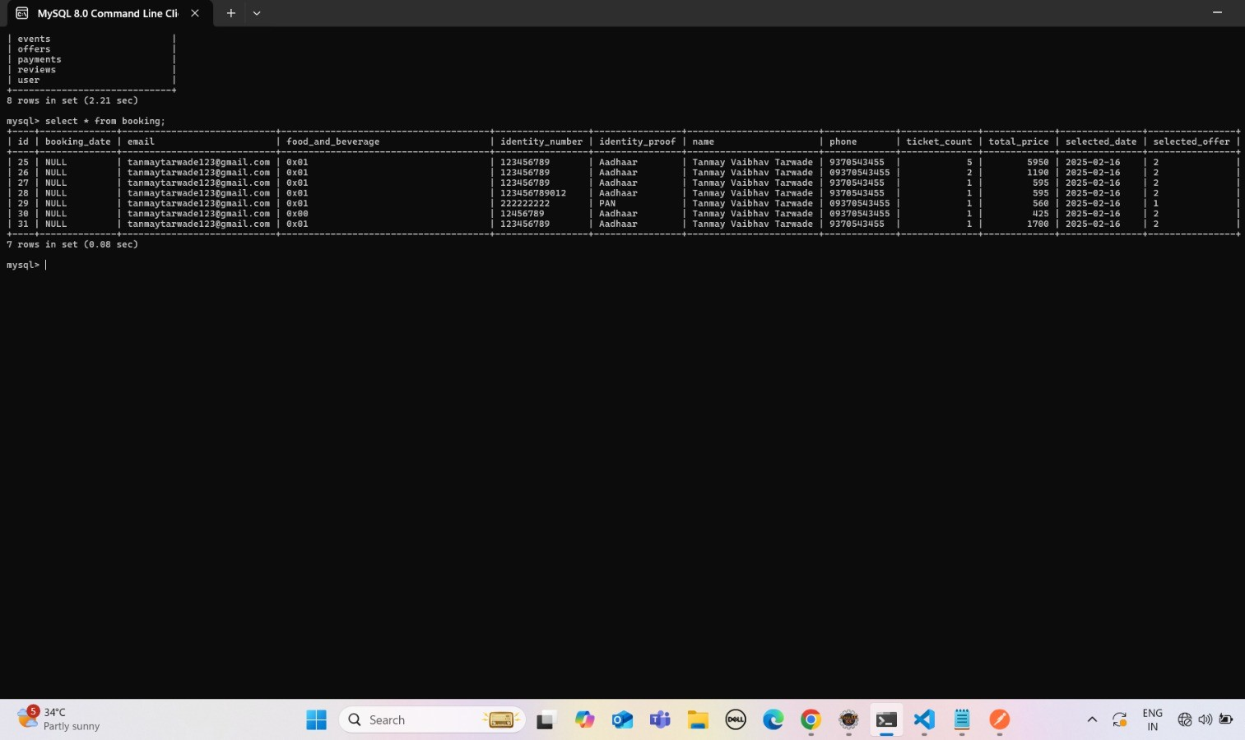

Booking Activity Table:

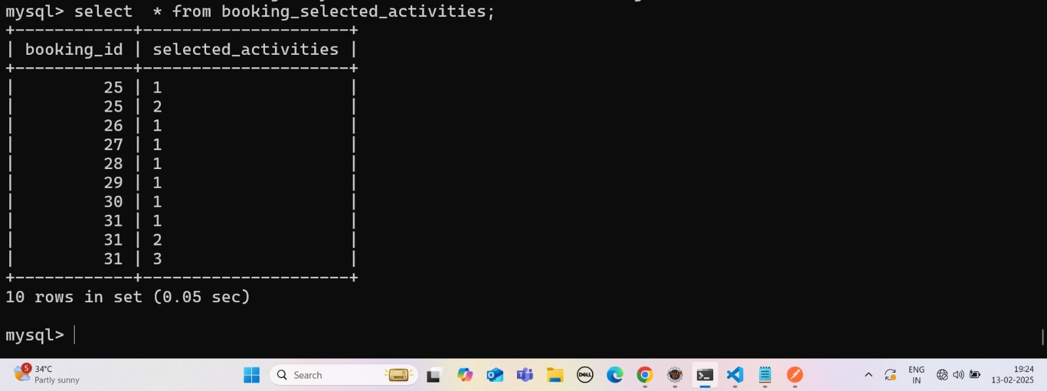

Offer Table:

Payment Table:

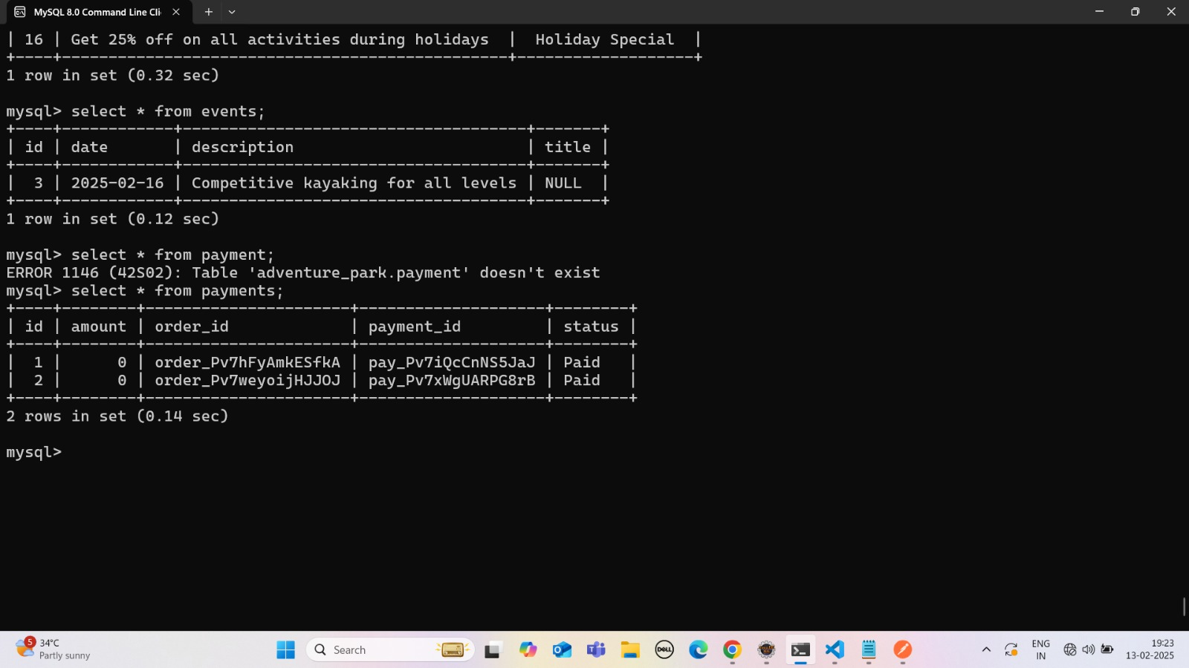

Event & Review Table:

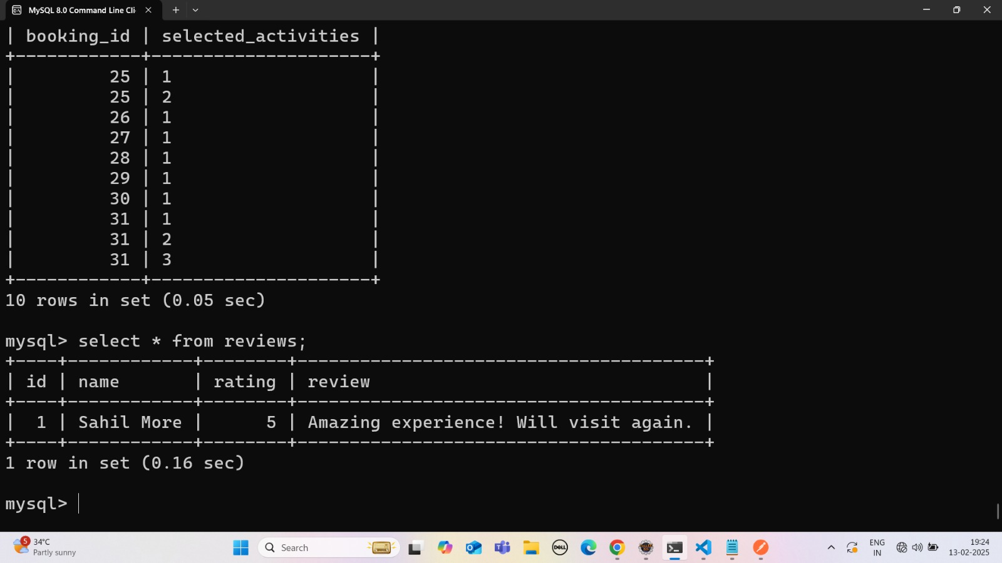

# 7. SCREENSHOTS

1. Home page-

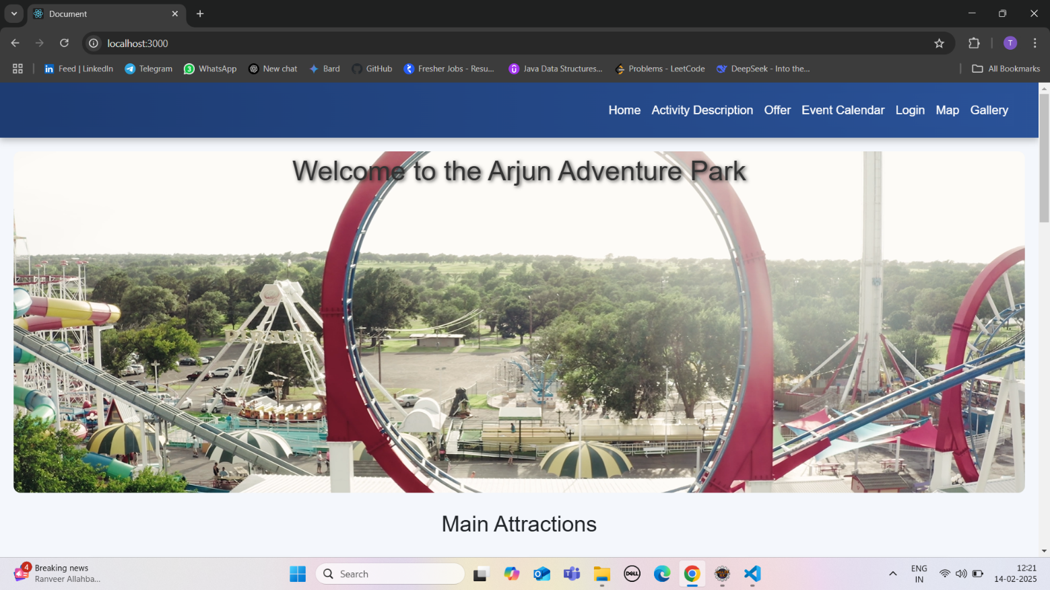

1. Login page-

1. User Registration page-

1. About page-

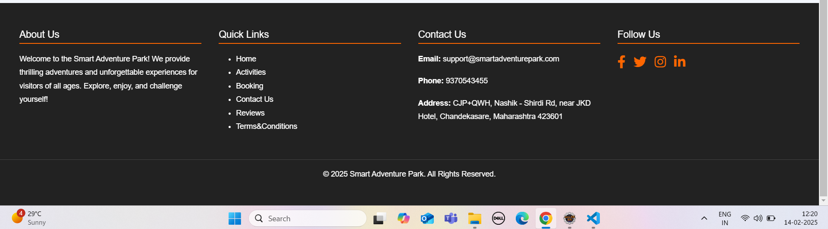

1. Time Allocation

1. Terms and Condition:

1. Weather based activity-

1. Map

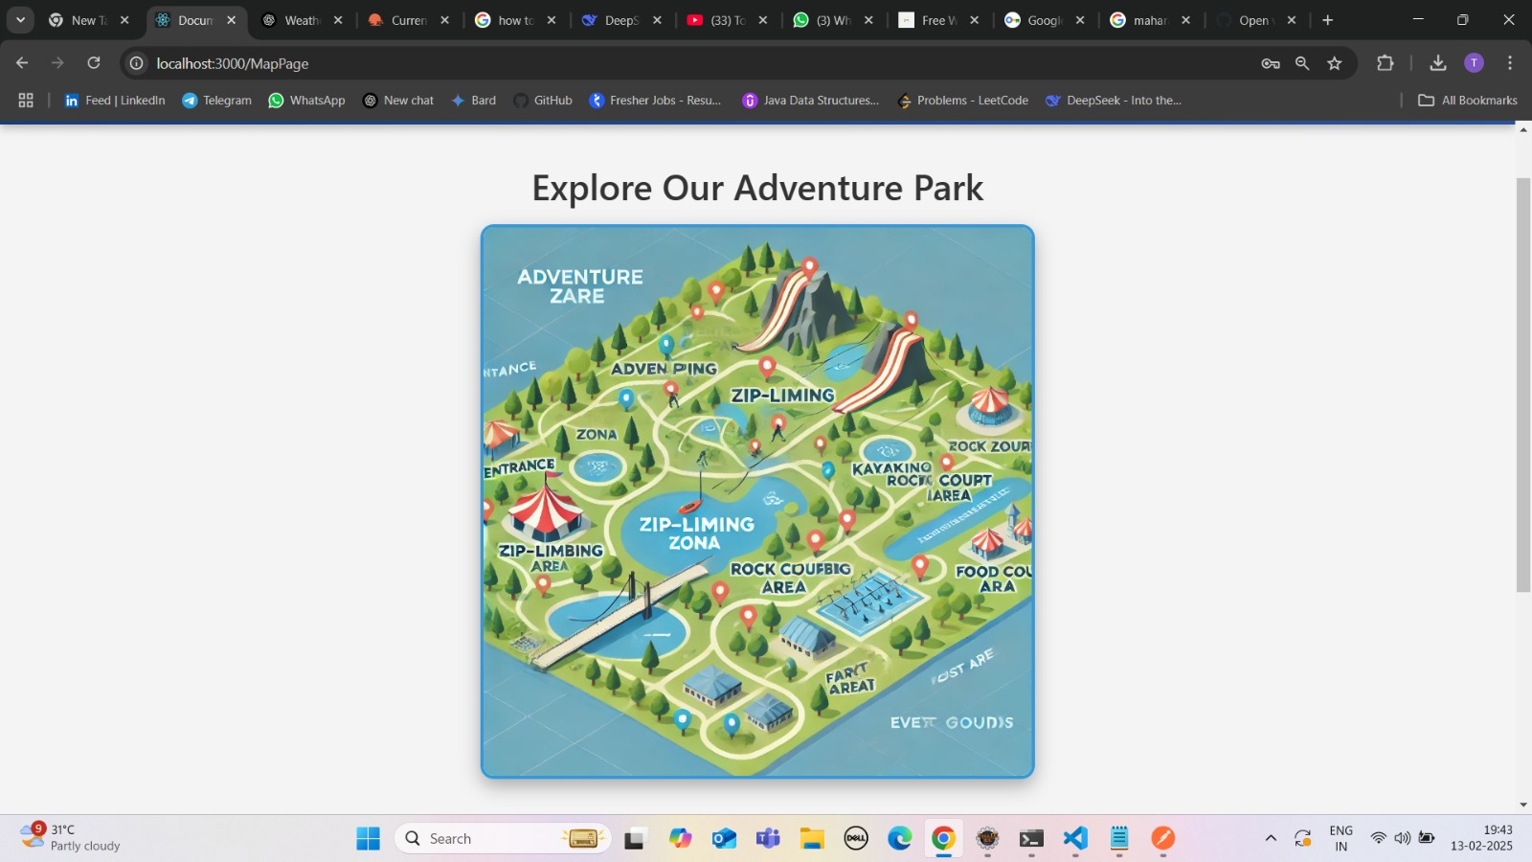

1. Gallery page-

# 6. CONCLUSION

The **Sky-High Adventure Park** presents a significant step forward in transforming how visitors experience adventure parks while also streamlining park management. By integrating advanced features such as activity booking, dynamic weather-based suggestions, secure payment gateways, smart queue management, and personalized itineraries, the system offers a seamless and engaging experience for users. Additionally, it improves operational efficiency for park management, reducing wait times, optimizing resources, and enhancing overall guest satisfaction.

Moreover, with the growth of the adventure park industry and an increase in digital adoption by users, this smart system can be adapted to a variety of parks, including theme parks, water parks, and resorts worldwide. By remaining flexible, scalable, and user-focused, the **Sky-High Adventure Park** can continue to evolve and remain a cornerstone in creating memorable, efficient, and customized experiences for all visitors in the years to come.

## Future Scope:

The **Sky-High Adventure Park** has considerable potential for growth and innovation in the future, as it continues to adapt to evolving technologies and visitor expectations. One of the key areas for future enhancement is the use of **Artificial Intelligence (AI)** and **Machine Learning (ML)** to further personalize the visitor experience. By analyzing visitor data, AI could offer more accurate activity suggestions based on past preferences, weather conditions, and real-time visitor feedback. Furthermore, AI-powered predictive analytics could optimize park operations, such as forecasting crowd density, managing staff allocation, and predicting popular activity demand during peak hours, ensuring smooth visitor flow and reducing wait times. And resource management will be essential in overcoming real-time challenges and ensuring its continued success in the future.

# 6.REFERENCES

**References:**

* + “Smart Tourism: Concepts and Methods” – Zheng Xiang, Daniel R. Fesenmaier
  + “Smart Parks: IoT-Based Intelligent Management of Amusement Parks” – IEEE Xplore
  + International Association of Amusement Parks and Attractions (IAAPA) – [www.iaapa.org](https://www.iaapa.org/)
  + Brown A., Kappes J., Marks J. (2013). Mitigating theme park crowding with incentives and information on mobile devices. *Journal of Travel Research*, 52(4), 426–436. <https://doi.org/10.1177/0047287512468467>[Google Scholar](https://scholar.google.com/scholar_lookup?title=Mitigating+theme+park+crowding+with+incentives+and+information+on+mobile+devices&author=A.+Brown&author=J.+Kappes&author=J.+Marks&publication_year=2013&pages=426-436&doi=10.1177%2F0047287512468467)